PHYSICS SS2 (FIRST TERM)

1. Concept of position, distance and displacement in relation to X-Y plane
2. Scalar and vector quantities: vector representation, addition of scalar and vector, resolution of vectors and resultant
3. Derivation of equation of motion, motion under gravity, calculation
4. Projectile and its application
5. Linear Momentum/Newton’s laws of motion
6. Equilibrium of forces
7. Equilibrium of forces ( center of gravity)
8. Simple harmonic motion(definition, displacement, acceleration, period and frequency
9. Simple harmonic motion(Energy of SHM),
10. Machines(types and examples)
11. Machines – calculation on machines
12. Revision/Examination

WEEK 1: **CONCEPT OF POSITION (X-Y PLANE)**

POSITION: this is precisely where an object is located. It can be on a plane or in space. One must specify a reference point, the distance of the object from the reference point and also the direction of the object from the reference point when describing the position of an object.

To represent the position of an object in space/plane a coordinate system is used. Coordinate system consist of axes(x, y) for plane and (x. y, z) for space and a reference point(origin). The Cartesian system is common when describing position of object.

Distance and Displacement will be consider (similarity and difference)

Displacement: change in position along a specified direction

CLASSWORK:

1. on a graph determine the following position A(0,5) B(4,-1) C(-3,-5) E(2,5)
2. Calculating distance between two point using AB =√(X₂ -X₁)² +(Y₂ - Y₁)²

WEEK 2: **SCALAR AND VECTOR QUANTITIES**

**SCALAR QUANTITIES**

Physical quantities which can completely be specified by a number (magnitude) having an appropriate unit are known as "SCALAR QUANTITIES".

Scalar quantities do not need direction for their description.

Scalar quantities are comparable only when they have the same physical dimensions.

Two or more than two scalar quantities measured in the same system of units are equal if they have the same magnitude and sign.

Scalar quantities are denoted by letters in ordinary type.

Scalar quantities are added, subtracted, multiplied or divided by the simple rules of algebra EXAMPLES

Work, energy, electric flux, volume, refractive index, time, speed, electric potential, potential difference, viscosity, density, power, mass, distance, temperature, electric chargeetc.

**VECTORS QUANTITIES**

Physical quantities having both magnitude and direction with appropriate unit are known as "VECTOR QUANTITIES".We can't specify a vector quantity without mention of direction. Vector quantities are expressed by using bold letters with arrow sign. Vector quantities cannot be added, subtracted, multiplied or divided by the simple rules of algebra. Vector quantities added, subtracted, multiplied or divided by the rules of trigonometry and geometry.

EXAMPLES

Velocity, electric field intensity, acceleration, force, momentum, torque, displacement, electric current, weight, angular momentum etc.

|  |  |
| --- | --- |
| Scalars are physical quantities which have magnitude but no direction | Vectors are physical quantities which have both magnitude and direction |
| Examples: length, mass, time and speed | Examples: displacement, velocity, force and acceleration |

**CLASSWORK**

Classify the following quantities either as scalar or vector: pressure, electric potential, impulse, momentum, acceleration, electric field, electric current

Vector is represented by a line with an arrow. The length of the line represents the magnitude while the arrow shows the direction of the vectors. On paper vector quantities are represented by a straight line with arrow head pointing the direction of vector or terminal point of vector.

**ADDITION OF VECTORS**

The addition of two vectors A and B gives a third vector R which is known as the resultant of the two vectors.

(a) the two vectors can be acting in same direction (along the same straight line): add  
(b) the two vector can be acting in opposite direction (along the same straight line): subtract

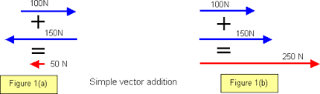

(c) the two vector can be acting perpendicular to each other: tail to tip method(also refer to as Pythagoras method)

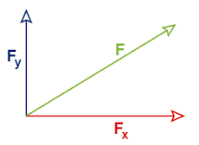

RESOLUTION OF VECTOR

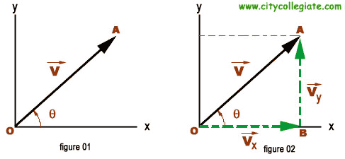

A single vector can be replaced by two components acting along the perpendicular directions. These are the resolved component along the direction.

The x-component of a vector Fₓ = F cosθ  
The y-component of a vector Fᵧ= Fsinθ  
The relationship between the force and the resolved component is found using Pythagoras theorem  
 F² = (Fₓ) ² + (Fᵧ)²

The angle θ = tan-¹(Fᵧ/Fₓ)

**PARALLELOGRAM LAW OF VECTORS**:

States that if vectors are represented by the two adjacent sides of a parallelogram, the resultant is represented in magnitude and direction by the diagonal of the parallelogram from the point of intersection of the two sides.   
 R² = A² + B² - 2ABcosØ

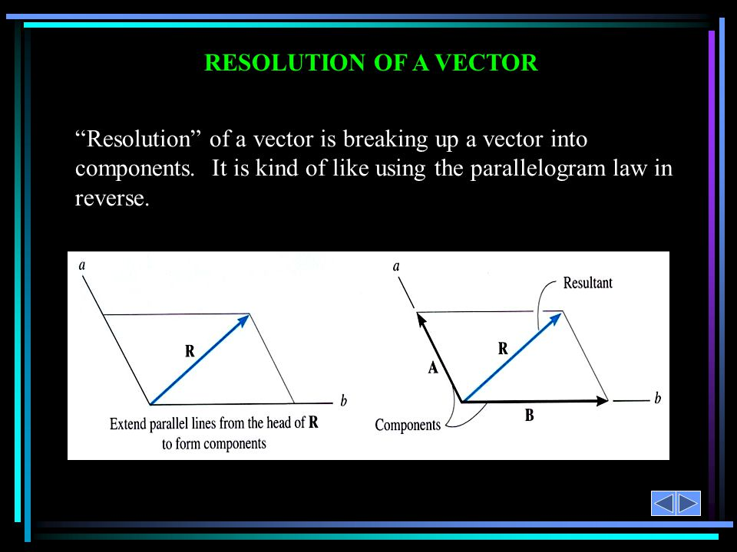

N.B: Students should note when the angle is less than 90⁰ and when it is greater than 90⁰

RESOLUTION OF TWO OR MORE FORCES

10cos 10° N

10sin 10° N

8sin 40° N

8cos 40° N

8cos 40° N

8sin 40° N

8 N

8 N

10 N

*P*

*Q*

40°

40°

130°

10°

**SOLVED EXAMPLES/CLASSWORK** ** ANALITICAL METHOD** GRAPHICAL METHOD** ON RESOLUTION OF TWO OR MORE FORCES**

WEEK 3: DERIVATION OF EQUATIONS LINEAR MOTION

The following terms are associated with motion   
Initial velocity (u), final velocity (v), distance (s) and time (t).  
The equations of motion can be derived from the equations given below

1. Acceleration = $\frac{\left(v-u\right)}{t}$
2. Average velocity = $\frac{\left(u+v\right)}{2}$

The equations of motion are:

s = $\frac{\left(u+v\right)}{2} x t$……………………………….. (*)

v = u + at ……………………………….. (1)

v² = u² + 2as ……………………………….. (2)

s = ut + 1/2at2……………………..(3)

********** show derivation of the above formula****************  
********** Solved questions using equations of motion/Classwork****************

MOTION UNDER GRAVITY

The equations of motion of a body moving under gravity are obtained by replacing “s” and “a” of the equation by h and g

1. v = u ± gt
2. h = ut ± gt2
3. v2 = u2 ± 2gh

Acceleration due to gravity is the earth’s pull on every object. Also, it is the force per unit mass of a body or every object. It is known as force of attraction on every object by the earth.

PROJECTILE MOTION

**Projectile motion** is a curved motion with constant acceleration or the motion of an object projected into the air at an angle θ with respect to the ground. The path followed by a projectile is called a trajectory.   
 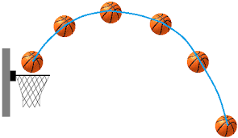

Examples includes

1. missile shot from gun
2. tennis ball hitting the table
3. stone shot from a catapult
4. golf ball in flight

The flight of a projectile motion is shown below

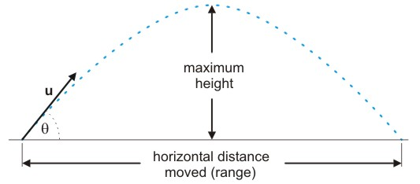

Formulae related to projectile motion are:

1. Time of flight T = $\frac{2U sinθ}{g}$
2. Maximum height H= u2sin2θ/2g
3. Range R = u2sin2θ/g [maximum range θ = 45° ]

Derivation of the above formulae:

Assuming that Q is the point where the particles meet the target. Let T be the time of flight at Q, the vertical displacement is zero.  
s = u sinθt – gt2  
0 = u sinθt – gt2  
 usinθt = gt2  
t = usinθ/g  
T = 2usinθ/g

Horizontally, considering the range covered:   
s = R = u cosθt  
R = u cosθ X usinθ/g = 2u2sinθcosθ/g = u2sin2θ/g

For maximum height H,   
v = u2 sin2θ – 2gH (at maximum height, v = 0)  
0 = u2 sin2θ – 2gH  
u2 sin2θ = 2gH  
H = u2 sin2θ / 2g

********* Solved Questions on Projectiles involving Angles****************

APPLICATION  
The knowledge of projectile is found useful in

1. Warfare
2. Sport

HORIZONTAL PROJECTILE: Involves the use of equations of motion

********* Solved Questions on Projectiles involving Horizontal projectiles****************

WEEK 5: NEWTON’S LAWS OF MOTION/LINEAR MOMENTUM

Linear momentum (p): This is product of mass and velocity of a body in motion.  
 p = mv …… kgm/s

Impulse: This is the product of force and time acting on a body.

Impulse I = Ft   
Impulse and momentum are also measured in Ns

Inertia: This is the tendency of a body to remain in their state of rest or uniform motion in the absence of any applied force.

NEWTON’S FIRST LAW: It states that every object will continue to be in its state of rest or uniform motion in a straight line unless acted upon by an external force.

NEWTON’S SECOND LAW: It states the rate of change of momentum is proportional to the applied force and takes place in the direction of that force

F α $\frac{change in momentum}{time taken}$

F = $\frac{mv-mu}{t}$ = $\frac{m(v-u)}{t}$ = ma

Ft = $mv-mu$ ( impulse = change in momentum)

NEWTON’S THIRD LAW: This states that for every action there is an equal and opposite reaction OR action and reaction are equal but opposite.

Weight Of A Body Inside A Lift:

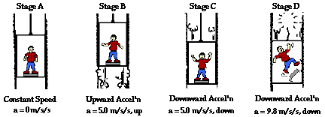  
The following cases will be considered

1. When the lift is at rest: There is no force acting on the object, weight = normal reaction W = R = mg
2. When Lift is moving with uniform velocity(up or down): The weight and the reaction are equal, hence R – mg = ma = 0 (since a = 0) [lift moving up]

Also mg - R = ma = 0 (since a = 0) [lift moving down]

1. Lift moving up with acceleration a,

R – mg = ma

R = mg + ma = m(g + a)

1. Lift moving down with acceleration a,

mg - R = ma

R = ma - mg = m(a - g)

1. During free fall( a = g) , it will experience weightlessness

mg - R = ma

R = ma - mg = m(a - g) = 0

R = weight of object = 0

**************solved Examples*****************

CONSERVATION OF LINEAR MOMENETUM

The principle of conservation of momentum states that the total momentum of a close system of colliding bodies are constant or the total momentum before collision is equal to total momentum after collision in a closed system.

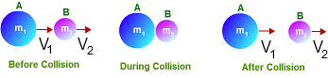

Total momentum before collision = Total momentum after collision  
 mAuA + mBuB = mAvA + mBvB

Collision are basically two types

1. Elastic Collision: momentum and kinetic energy are both conserved. Examples of collision that are nearly perfectly elastic are collision of billiard balls and table tennis.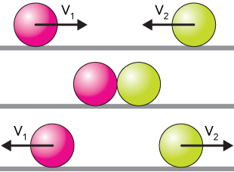  
   mAuA + mBuB = mAvA + mBvB ………………………………………. momentum

mAuA2 + mBuB2 = mAvA2 + mBvB2……………………………………….kinetic energy

1. Inelastic Collision: only momentum is conserved. The kinetic energy is transformed into other form of energy such as sound and heat energy(hence decrease in K.E). For perfectly inelastic collision, the bodies will stick and move off together as one after collision.

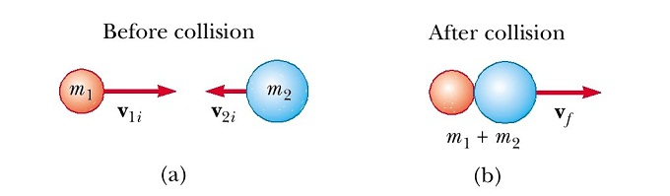

mAuA + mBuB = mAvA + mBvB = (mA + mB)v……………………………………. momentum

mAuA2 + mBuB2 …………………Energy before collision

mAvA2 + mBvB2 = (mA + mB) v2 …………………Energy after collision

N.B: Various Cases of inelastic collision. For inelastic collision, kinetic energy before > kinetic energy after

APPLICATIONS OF NEWTON’S LAWS AND CONSERVATION OF LINEAR MOMENTUM

1. Recoil of a gun: When a gun is fired, it jerks backwards(recoil). The action force that propels the bullet forward is equal but opposite to the reaction force that causes the gun to recoil backward.
2. Jet Aeroplane: The jet aeroplane releases stream of very highly compressed hot gas (it has high velocity and very high momentum). The momentum of the steam of gases causes an equal and opposite momentum to be imparted to the aeroplane making the aeroplane move forward at very high speed.
3. Rocket Propulsion: Work on the same principle as that of a jet. The difference is that jet engines take their oxygen from supply directly from the atmosphere, rocket engines carry their own oxygen supply(why?)

****************solved Questions ******************

WEEK 6: Equilibrium of forces

A body is said to be in equilibrium if it fails to move or rotate under the action of a system of forces.  
A body that is at rest with no net force acting on it is said to be in static equilibrium while a body that maintains constant linear velocity or rotates with constant angular velocity is said to be in dynamic equilibrium.

Resultant force: is the single force which will have the same effect in magnitude and direction as two or more forces acting together.

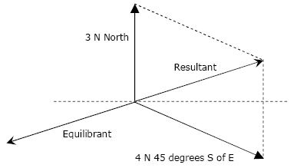

Equilibrant force: is that single force which will balance all the other forces taken together. It is equal in magnitude but opposite in direction to the resultant force.

TRIANGLES OF FORCES

The principle of triangle of forces states that if three forces are in equilibrium, they can be represented in both magnitude and direction by the three sides of a triangle.

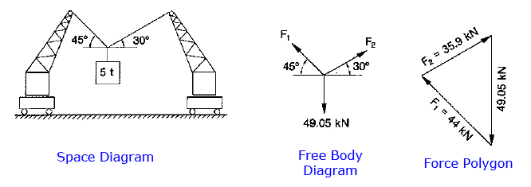

**********SOLVED SAMPLE QUESTIONS**********

MOMENT OFA FORCE  
The moment of a force about a point is the product of the force and perpendicular distance of its line of action from the point.  
Moment of force = Force (F) x perpendicular distance (d)

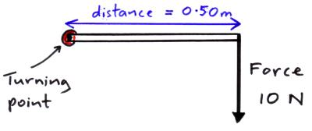

For a force that acts at an angle θ to d, the perpendicular distance from the pivot to the line of action of the force is d = rsinθ

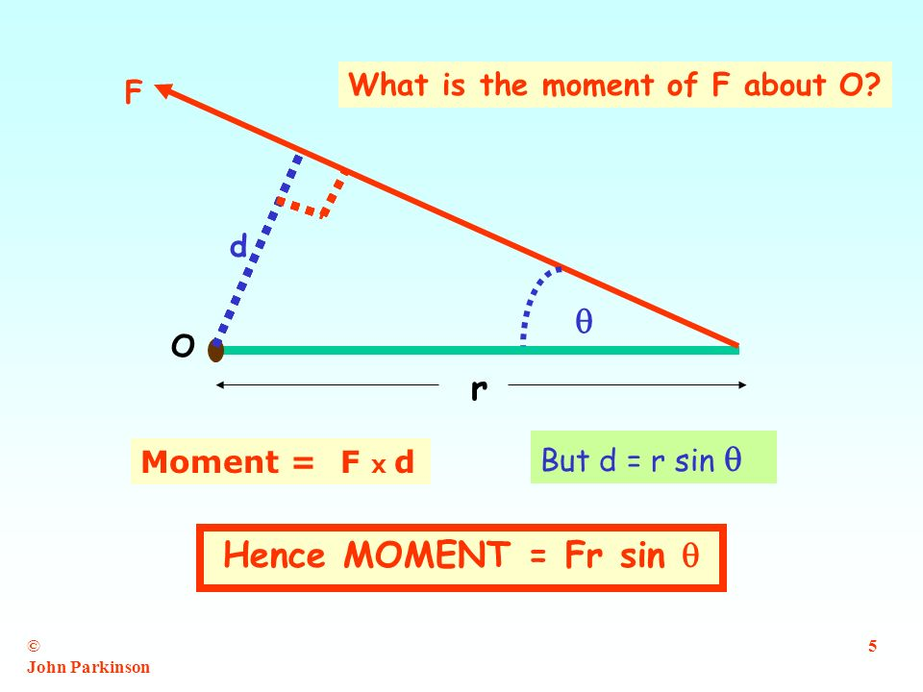

PRINCIPLE OF MOMENTS

The principle of moments states that if a body is in equilibrium, then the sum of the clockwise moments about any point on the body is equal to the sum of the anticlockwise moments about the same point.

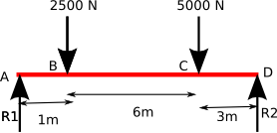

CONDITIONS FOR EQUILIBRIUM

1. Forces: the net force acting on the object = 0. The total upward forces equal the total downward.
2. Moments: the sum of the moments acting on the object about any point = 0. That is the sum of the clockwise moments equals the sum of the anticlockwise moments about the same axis.

COUPLE  
Two forces which are equal in magnitude and opposite in direction, and whose lines of force do not coincide constitute a couple. It result in rotational motion but not in translational motion.

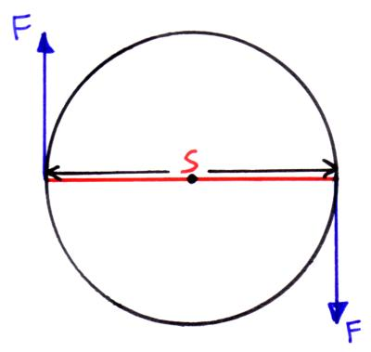

For a couple with the two forces F acting opposite to each other, a distance s, the moment is given by   
Moment = F x s

WEEK 7: CENTER OF GRAVITY

The centre of gravity of a body is defined as the point through which the resultant of the weights of all the particles of the body acts.

TYPES OF EQUILIBRIUM.

The three types of equilibrium are:

1. Stable equilibrium.
2. Unstable equilibrium.
3. Neutral equilibrium.

The stable equilibrium.

An object is in stable equilibrium when it is slightly displaced, the weight of the object tends to increase the displacement of the object in unstable equilibrium lowers the centre of gravity of the object.

The neutral equilibrium.

A neutral equilibrium of an object is when it is slightly displaced, it remains in its new position without changing the centre of gravity.

WEEK 8: Simple harmonic motion

Simple Harmonic Motion is define as the motion of an object whose acceleration is always directed towards a fixed point and directly proportional to the distance from that point.

The following are examples of SHM

1. Vibration of body suspended by a spiral spring.
2. To and fro movement of a pendulum bob.
3. The vibration of a tuning fork.
4. Up and down movement of a loaded test tube floating in a liquid.

DEFINITION OF TERMS

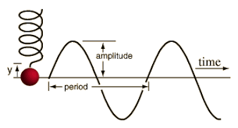

1. Amplitude(y): The amplitude of a SHM is the maximum displacement of the body from the fixed point.
2. Period(T): The time taken by the object to make to make a complete circle ie it moves through 3600 or 2π radians ie

T = 2π/ω

For a simple pendulum ω = $√\frac{g}{l}$

For a vibrating spring ω = $√\frac{k}{m}$ = $√\frac{g}{e}$

Where g = acc due to gravity, l = length of pendulum, e = extension of the spring, m = oscillating mass, k = restoring force per unit displacement.

>>>> deduce how the period for simple pendulum is T = 2π $\sqrt{\frac{l}{g}}$ and for a vibrating spring T = 2π $\sqrt{\frac{e}{g}}$ = 2π $\sqrt{\frac{m}{k}}$. For a loaded test tube T = 2π $\sqrt{\frac{m}{Aρg}}$

1. Frequency(f): this is the number of complete cycles per second.

f= $\frac{1}{T}$ = ω /2π

1. Speed/Velocity of SHM: For object undergoing circular motion, the linear velocity is given by   
   v = ωr  
   but for SHM the linear speed/velocity is given

v = ωr2 – y2 where r = radius of the circle, y = amplitude/displacement from fixed position. The range of y is from zero to the amplitude of the displacement, hence maximum velocity is attained when the displacement y = 0.

1. Acceleration of a SHM:Recall that the acceleration of a SHM is always directed towards a fixed point and that it is proportional to its distance from the fixed point. The distance from the fixed point is the displacement y, acceleration is given by a = -ωy2. Maximum acceleration is when displacement is maximum.

ENERGY OF A SHM.

There are energy changes when a body undergoes SHM eg a pendulum bob has maximum P.E. when it is at maximum displacement position but when it passes the equilibrium position, the PE is minimum while KE is maximum since the bob is moving at maximum velocity.

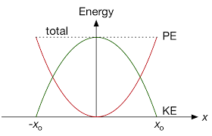

K.E. IN SHM = mω2r2, at maximum displacement(amplitude) KE = 0. Maximum K.E. occurs when amplitude = 0

P.E. IN SHM = mω2y2.When the body is at amplitude, P.E is at maximum. Minimum P.E.occurs when amplitude = 0.

Total Energy is given by   
T.E. = P.E. + K.E. = mω2r2+ mω2(r2-y2) = mω2y2

>>>>>>>>>>>> SOLVED QUESTIONS ON SHM >>>>>>>>>

MACHINES

A machine is any device that enables work to be done easier and faster.

TERMS ASSOCIATED WITH MACHINE.

1. Mechanical Advantage(M.A.) = $\frac{load}{effort}$ = $\frac{output force}{input force}$
2. Velocity Ratio = $\frac{distance moved by effort}{distance moved by load.}$
3. Efficiency = $\frac{Useful work done by effort}{Work put into machine.}$ X 100 = $\frac{work output}{work input}$ x 100.
4. >>> deduce the formula Efficiency = = $\frac{M.A.}{V.R}$ x 100.

CLASSIFICATION OF MACHINES

1. The lever
2. Pulleys
3. Inclined plane
4. Screw or screw jack
5. Hydraulic press
6. Wheel and axle.

LEVER

This is the simplest form of machine. It is a rigid body pivoted about a point called a fulcrum (F). An effort E is applied at one point on the lever and this overcomes a load (L) at some other point. A level is of three types : first class, second class and the third class.

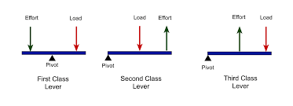

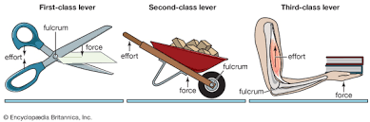

PULLEYS:

Pulley is a fixed wheel with a rope passing through a grove in its rim. A load L is attached at one end of the rope, effort E is applied at the other end. The velocity ratio of a pulley system is equal to the number of pulleys (n) present. The M.A. increases as n increases

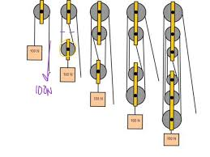

Inclined Plane

It is a slopping surface that makes the work of raising an object easier due to the weight of the object.

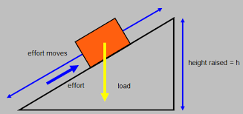

V.R. = $\frac{distance moved by effort}{distance moved by load}$ = $\frac{1}{\sin{θ}}$

SCREW / SCREW JACK

The distance between successive screw thread is called the pitch (p).

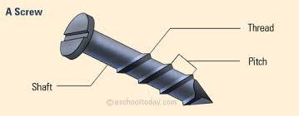

V.R. = $\frac{2πr}{p}$,

If frictional forces are negligible the V.R. = M.A.

WHEEL AND AXLE

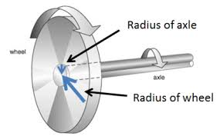

V.R. $\frac{distance moved by effort}{distance moved by load}$ = $\frac{2πR}{2πr}$ = $\frac{R}{r}$

GEAR WHEEL

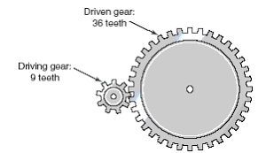

V.R. = $\frac{Number of teeth on driven wheel }{Number of teeth on driving wheel }$